HELLOWIN.C IN DEPTH

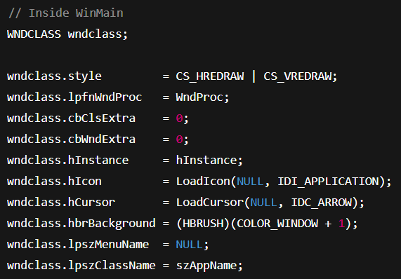

**🧠 What's Happening Here?**

Okay, we had a lot of notes over here, but it’s all a repeat of chapter 2, so we are going to just revamp this a bit, remove all the repetition, and get moving to the next chapter.

This snippet sets up the WNDCLASS struct — which you've seen already — but in the **context of a full Win32 GUI app** (HELLOWIN.C style). Every field is configured to give our window:

* *Redraw behavior on resize*.
* *A default icon and cursor*.
* *A background color*.
* *A class name (usually the app name)*.
* *No menu*.
* A pointer to a message handler (WndProc).

After this, the next logical step is a call to RegisterClass(&wndclass) — **then the real fun begins** in WinMain: window creation and the event/message loop.

⚙️ HELLOWIN.C — Part 2: Registering the Window Class

🧱 RegisterClass Recap

Once the WNDCLASS structure is fully initialized, we register it with the Windows OS using:



This call is essential — it tells Windows:

*"Hey, here's a new window blueprint (class) you can use to build windows."*

If registration fails, we handle it (as we saw earlier) with a message box and a return 1;.

🧠 Window Procedure Refresher

The **lpfnWndProc field** in WNDCLASS is a pointer to our **message-handling function**, WndProc.

This function responds to messages like:

* **WM_CREATE:** Window is being created.
* **WM_PAINT:** Needs to repaint content.
* **WM_DESTROY:** Window is closing — time to quit.



⭕ Extra Space Fields (Usually Zero)



These two fields let you reserve custom memory for class-wide or per-window data. Most of the time, they’re left at zero unless you’re building something very custom.

🔗 Instance Handle



This handle represents the running instance of your application — it’s passed to WinMain and is required when loading resources or creating windows.

🖼️ Icons and Cursors

Set the default icon and cursor for all windows of this class:



* **IDI_APPLICATION:** Basic app icon
* **IDC_ARROW:** Standard mouse pointer

🎨 Background Brush



This sets the background color of the window’s client area.  
You’ll see COLOR_WINDOW+1 or WHITE_BRUSH commonly used here.

✅ Final Steps

Once the structure is set up with:

* Class styles.
* Message handler.
* App resources.

…it’s registered via **RegisterClass**, and we’re ready to create a window using this class name.

Finalizing and Registering the Window Class

🍽️ Menu or No Menu?

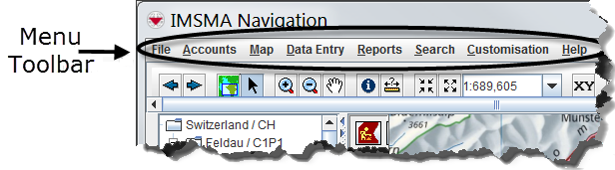



This line simply tells Windows:

* *“No menu bar for this window class.”*
* *If you ever need one, you'd link it to a resource defined in a .rc file.*

🏷️ Naming Your Window Class



This sets a name for the window class. You’ll use this string later in CreateWindow to say: *“Create a window from this class.”*

📌 Depending on whether UNICODE is defined, this string can be ASCII or wide-character (Unicode). That’s handled under the hood by type aliases like LPCTSTR.

🧠 RegisterClass: One Function, Many Flavors



This function registers your class with Windows so it knows how to create windows from it.

**There are 3 versions:**

* **RegisterClassA** – ASCII version.
* **RegisterClassW** – Unicode version.
* **RegisterClassEx** – Extended version (adds a few extras).

Which one gets used depends on whether UNICODE is defined during compilation.

🐛 Compatibility Notes (Legacy Windows)

If UNICODE is defined and you're running on old systems like Windows 98, calling RegisterClassW may silently fail. Why?

**➡️ Windows 98 had a stub for RegisterClassW**, but it wasn’t actually implemented.

To catch this:



* **MessageBoxW** is one of the few Unicode APIs that actually works in Windows 98.
* Use **GetLastError()** to find the reason — if it returns **120**, that's ERROR_CALL_NOT_IMPLEMENTED.

🧹 Do You Need to Check Every Error?

In production code? Absolutely.

In beginner tutorials like this? Not always.  
The goal is clarity — not guarding against every edge case.

💡 Pro tip: Always check **critical calls** like memory allocation or file access. For others (like RegisterClass), it’s okay to keep things simple unless debugging an issue.

HISTORICAL CONTEXT OF HPREVINSTANCE CHECK

🕰️ Historical Context of hPrevInstance

In **16-bit Windows**, the hPrevInstance parameter in the WinMain function was used to manage multiple instances of the same application.

When launching a new instance, hPrevInstance would hold the instance handle of the already-running application. This allowed **memory optimization**, as the same window class could be shared across instances.

The 16-bit Behavior:

* If hPrevInstance was not NULL, the window class was **not re-registered**, saving memory.
* If hPrevInstance was NULL, it meant no instance of the application was running, so the window class was registered.

The 32-bit Change:

With the transition to 32-bit Windows, **hPrevInstance is always NULL.** This was a consequence of changes to the way Windows manages memory and instances. As a result:

* The check for hPrevInstance before registering the window class became **redundant**.
* In modern Windows programming, **it's safe to directly register the window class** without worrying about hPrevInstance.

TLDR:

* **16-bit Windows** used hPrevInstance for instance management.
* **32-bit Windows** always sets hPrevInstance to NULL, making this check obsolete.

**Don't check hPrevInstance; just register the class directly.**

**🧱** WINDOW CLASS VS. WINDOW: WHAT'S THE DIFFERENCE?

The **Window Class** defines the **blueprint** for windows with similar behavior and attributes. It encapsulates the **default behavior**, **appearance**, and **functionality** for a type of window, such as buttons or text boxes.

On the other hand, a **Window** is a **specific instance** created from that class. It has:

* **Unique positioning** (where it’s placed on the screen).
* **Custom sizing.**
* **Specific content** (like text or images).

Example: Push Buttons

* All push buttons in a program are instances of a **single window class** that defines their basic behavior (e.g., responding to mouse clicks).
* But each button may have **different text** ("OK", "Cancel"), **sizes**, or **positions** in the UI, specified when it’s created using CreateWindow.

TLDR:

* **Window Class** = The template (e.g., all push buttons share the same class).
* **Window** = The actual object you see on screen (e.g., a button with specific size, location, and text).

🚀 Key Takeaways:

1. **hPrevInstance check is outdated** — no need for it on 32-bit systems.
2. **Window classes provide a template** for creating similar windows, while individual **windows** are specific instances based on that class.

The window class represents a general category of windows, while the window represents a specific instance of that class.

This separation allows for efficient memory management and code reuse.



🧠 Quick Memory Hack:

* The first 3 params define what kind of window it is.
* The next 4 are about position and size.
* The last 4 are about relationships and ownership.

*Note-taking isn’t about writing an encyclopedia. It's about making things click for your future self.*

*Just capture enough to understand the concept when you come back — you can always Google the rest. The internet’s not going anywhere.*

*And let’s be real: software engineering is about building things that work, not memorizing everything like a human textbook.*

📍 What does CW_USEDEFAULT *actually* do?

When you pass CW_USEDEFAULT for the x, y, width, or height params in CreateWindow, you’re telling Windows:

***“You figure this out. I don’t care. Just make it work.”***

Windows then auto-positions the new window in a slightly offset “cascading” layout so it doesn't stack directly over previous ones. It's designed to avoid overlap and to keep new windows visible and organized.

💢 Example: Why It’s Cool

Let’s say you launch your app three times, and each time the code uses:

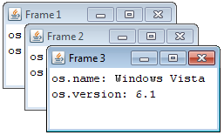



Windows might place them like this:

*1st window: Top-left.*

*2nd window: Slightly lower & to the right.*

*3rd window: Even further down & right.*

This behavior is subtle, but super user-friendly. It’s one of those "Windows does it for you" things that beginners don’t notice but devs love.

✍The Handle Return: Already Handled (👀 pun intended)

Everything else about the returned HWND (the handle to the window) was **already well-covered** in Part 2. We've already explained:

* It's a system-assigned ID.
* It’s needed to show, move, or destroy the window.
* You never manipulate windows directly — you always go through their handle.

So, no need to restate that again.

🆚 CreateWindowA vs CreateWindowW: Quick Mention Only

We already explained the ANSI vs Unicode stuff earlier too. Maybe just keep a **one-liner reminder** like:

⚠️ Reminder: CreateWindow is a macro that resolves to CreateWindowA (ASCII) or CreateWindowW (Unicode), depending on your build settings. Modern apps should always use Unicode (W) unless you're stuck supporting ancient systems.

✅ So What Do We Keep?

Just this section, rephrased clean for Part 3:

✨ Smart Window Positioning with CW_USEDEFAULT

When you create a window with CreateWindow, you can pass CW_USEDEFAULT for any of the position and size arguments:



This tells Windows:

*“Pick a default spot and size for me — I trust you.”*

Instead of just stacking all windows in the same corner, Windows automatically offsets them a little so they don’t overlap. It's like staggered sticky notes 🗒️ — you can see each one easily.

This keeps your UI tidy even if you create multiple windows without manually setting positions.

You can still override it with actual values if you want more control:



But for most apps? CW_USEDEFAULT keeps things clean and easy, especially during prototyping or for basic tools.

⚙️ Full Walkthrough: CreateWindow, ShowWindow, and Message Loop Explained

Step 1: Create the Window



🧠 **Reminder:** Windows gives you back a HWND — this is how your code refers to the new window from now on. You *never* deal with the raw window directly.

🎬 Step 2: Show the Window





⚠️ Without **ShowWindow**, your window stays hidden. Without **UpdateWindow**, it won't repaint until the OS decides it's time.

📨 Step 3: Set Up the Message Loop



This loop is the heart of every Windows GUI app. It never ends until WM_QUIT is sent — usually after the user closes the window.

📦 Deep Dive: MSG Structure Breakdown

This struct holds every detail about a message your app gets:



💡 WM_ messages are all over the place — e.g.:

* WM_LBUTTONDOWN – mouse left click
* WM_CHAR – a typed character
* WM_PAINT – redraw request
* WM_DESTROY – window closing
* WM_QUIT – message loop ends here



🚀 Want a Full Mini Example?

Here’s a tight skeleton that uses **everything above**:



🛑IMPORTANT: MESSAGE HANDLING ON WINDOWS

🧠 MESSAGE LOOP EXPLAINED

"Bro, your window is alive *because it keeps listening*."  
This is where you *listen* for keyboard/mouse/system events and *react* through messages.

Let’s walk through the full cycle.

🔁 Step 1: The Message Loop



🧵 What’s Happening Here?



⚠️ The loop keeps running **until GetMessage() returns 0**, which only happens when WM_QUIT is received.

🚪 Step 2: Program Exit — WM_QUIT and PostQuitMessage

Let’s say a user closes the window. Your WndProc function gets a WM_DESTROY message.

You handle it like this:



Now look at what GetMessage does:

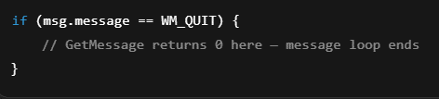  
That’s how the app knows it’s time to bounce 👋.

💬 Dig Deeper: Virtual Keys vs Characters

Why do we need TranslateMessage()?

Because:

* WM_KEYDOWN just tells you **which key was pressed** (like a code for “A”).
* But you often want the **actual character typed**, like 'A', 'b', or '3'.

TranslateMessage() figures that out and triggers a WM_CHAR message, which you can handle to grab actual characters (e.g., for a text editor).

🧱 Behind the Curtain: How Windows Talks

Let’s say this happens:

🖱️ User clicks the window  
⬇️ Windows: “Yo program, here's a WM_LBUTTONDOWN for that mouse click.”  
🧠 Your WndProc: “Got it — I’ll handle that message.”  
➡️ Returns control to Windows  
♻️ Windows: “Cool, next message?”

This cycle is the **heartbeat** of your app.

🧊 Bonus: What Happens If You Forget TranslateMessage()?

Your app will still run, and handle clicks, but...

😬 Keyboard input won’t generate characters, just virtual keys.  
That means no letters show up, no typed input works properly.  
So yeah — don’t skip it.

📦 Recap: Message Loop Flow



🧪 Visualization



This loop will keep your app alive until:



⚔️ Final Thoughts

* *GetMessage() blocks until something happens — this is why your app waits for user input.*
* *WM_QUIT is the only message that ends the loop.*
* *You control when that’s sent using PostQuitMessage.*
* *TranslateMessage is only for keyboard input refinement.*
* *DispatchMessage is what gets your messages to WndProc.*

Check the tables out my people!

Messages.WinAPI.001.html

Messages.WinAPI.002.html



























THE WNDPROC AND ITS FUNCTIONS

The **window procedure,** typically named **WndProc,** is the function responsible for processing messages sent to the window. It has a fixed structure:



The WndProc function is where **you** (the programmer) tell your program how to **respond** to system or user events.

Windows sends messages like:

* “The window is closing!”
* “The user clicked the mouse!”
* “Time to repaint the screen!”

And WndProc decides what to do with each one.

🧱 Basic Structure of WndProc



📦 Parameters — Matching MSG

This function receives four parameters that mirror the first four fields of the MSG structure:

* hwnd: The handle of the window receiving the message. This is the same handle returned from the CreateWindow function and uniquely identifies the window.
* message: An identifier representing the type of message, such as WM_PAINT for redrawing the window or WM_KEYDOWN for keyboard input.
* wParam: A 32-bit message parameter providing additional message-specific information. Extra info about the message (meaning depends on the message). Often holds integers or IDs.
* lParam: Another 32-bit message parameter providing additional message-specific information. More extra info — sometimes coordinates, sometimes pointers. Varies by message type.

These map directly to the fields inside the MSG struct from the message loop.

🔄 How WndProc Is Called

You **don’t** call WndProc directly. Instead, Windows calls it for you when it processes a message from your app’s message queue.

This happens when you call:



**DispatchMessage** is a function that takes a message from the message queue and sends it to the right window's WndProc to handle it.

This tells Windows:

*"Find the window the message belongs to, and then call its WndProc function to handle it."*

🚫 Direct Calls? Nope, Use SendMessage() Instead

In general, you **don’t call WndProc directly**. But if you need to send a message **manually** (which is rare in simple apps), you can use the SendMessage function.

**For example:**



This **sends a message (WM_SETTEXT)** to the window identified by hwnd, and directly calls its WndProc to process it—no need for DispatchMessage. It’s a way of forcing the window to handle the message right away.

Yes, **multiple windows created** from the same window class will all use the same WndProc. This helps keep behavior consistent across windows.

But if you want different behavior for different windows, you can **register a new window** class with its own **lpfnWndProc.**

Now, each window class can have its own **separate WndProc** to handle things differently.



And if it doesn’t recognize the message? It just passes it to:



🛠️ Sample WndProc for Beginners



🔥 In Simple Terms:

*WndProc is where you answer every knock at your program’s door.*

*Each message is a knock.*

*You open the door* ***(switch-case),*** *check what’s going on, and decide what to do.*

*If you don’t know the visitor? Send them to* ***DefWindowProc.***

INDIRECTLY CALLING WINDOW PROCEDURES

🧭 Indirect Message Sending: SendMessage

In most cases, your program **doesn't directly call** **its window procedure** (WndProc). Messages are sent by Windows when something happens — a key is pressed, a window resizes, the mouse moves, etc.

But if you ever need to **manually send a message to a window** — for example, to simulate a key press or change the window title — you can use:



This **calls the target window’s WndProc directly**, bypassing the message queue. It’s synchronous — meaning the call won’t return until the message is fully handled.

📌 SendMessage is useful when you want **immediate** control, like setting text, sending custom commands, or communicating between windows.

We'll dive into specific examples (like WM_SETTEXT, WM_COMMAND, etc.) in later sections.

😎 One WndProc, Multiple Windows

If you create **multiple windows using the same window class**, all those windows will share the same WndProc. This is common when you want consistent behavior across similar windows — like multiple instances of a text editor, or reusable tool windows.

However, if you need **different behavior** for different window types, you can:

* *Create a separate window class.*
* *Assign a different WndProc when registering that class.*

This lets each window type handle messages in its own way.

🔄 The Role of WndProc in Message Handling

The WndProc function plays a **critical role** in a Windows application. It’s where your program:

* *Handles input (mouse, keyboard)*
* *Responds to system events (resize, close, repaint)*
* *Executes app logic tied to UI actions (menu clicks, button presses)*

Each message sent to your window is represented by a **unique constant**, like WM_PAINT, WM_KEYDOWN, or WM_DESTROY. These are defined in the **winuser.h** header and start with WM_.

🎯 How Messages Are Handled

The standard way to process messages in WndProc is with a switch statement:



🧠 Why Use DefWindowProc?

If you don’t handle a message, you must call:



🤖This built-in Windows function ensures the system performs default behaviors:

* **Resizing or moving the window.**
* **Minimizing/maximizing.**
* **Processing keystrokes that aren't app-specific.**
* **Handling system commands like Alt+F4, right-click title bar, etc.**

⚠️ What Happens If You Skip It?

If you *forget* or *intentionally ignore* DefWindowProc:

* **The close button (**❌**) might stop working.**
* **The window might stop redrawing correctly.**
* **Keyboard navigation or tabbing between controls could break.**
* **System-level commands like moving or resizing the window may fail.**

In short: your app stops behaving like a Windows app and starts acting broken.

🧪 Example: Handling Common Messages in HELLOWIN.C

WM_CREATE

WM_CREATE is sent **once**, immediately after the window is created (via CreateWindow) — **before it's displayed**.

It’s the perfect place to:

* Load resources
* Set up graphics
* Start timers
* Play a welcome sound
* Initialize state variables

WM_PAINT

* Sent when the window’s content needs to be drawn or refreshed
* Use BeginPaint, draw text/images, then call EndPaint

WM_DESTROY

* Sent when the window is closing.
* Use PostQuitMessage(0) to exit the message loop.

These messages are enough to handle the **basic lifecycle** of a window: from creation, to display, to cleanup and exit.

✅ Summary: WndProc Essentials



🎵 WM_CREATE in HELLOWIN – Playing a Startup Sound

When a window is successfully created using CreateWindow, Windows sends a WM_CREATE message to its window procedure. This is your app’s **initialization hook** — the moment to set up anything needed before the window appears on screen.

📌 How HELLOWIN Handles WM_CREATE:

In HELLOWIN.C, the app plays a .wav file named HELLOWIN.WAV as a **startup sound cue**:



🔊 PlaySound — How It Works

The PlaySound function plays a waveform audio file. It's defined in the Windows Multimedia API (**winmm.lib**), and you may need to link it during compilation.

**✅ Parameters:**





pszSound - Name of the sound file to play — in this case, "HELLOWIN.WAV".

hMod - Handle to the module if the sound is a resource. NULL if it's a file.

dwFlags - Playback options. SND_ASYNC tells Windows to play the sound in the background.

🔁 Why SND_ASYNC?

* It lets the sound play **without freezing the app**
* Your program can keep running and initializing
* Ideal for startup cues, notifications, etc.

📌 **If you leave out SND_ASYNC,** the app will pause until the sound finishes — not what you want for smooth UX.

✅ Return Value from WM_CREATE

After handling WM_CREATE, return 0 to tell Windows:

*“Initialization successful. Keep going.”*

Failing to return 0 could interrupt CreateWindow and prevent the window from being fully initialized.

🎨 Next Up: WM_PAINT — Drawing the Window

After a window is created, resized, or uncovered, Windows sends a WM_PAINT message. This tells your app:

*“Redraw your client area now.”*

This message is crucial in any GUI program — it’s your chance to render the **actual content** of your window.

We’ll cover WM_PAINT fully in the next section — how to use BeginPaint, draw text or shapes, and handle repaint cycles properly.

WM_PAINT

🧠 What Triggers WM_PAINT?

A WM_PAINT message is sent when **Windows determines** that all or part of your window’s **client area** (the drawable area inside the window, excluding title bar/borders) needs to be **redrawn**.

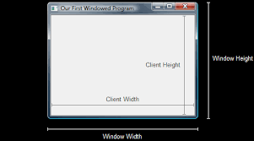

🧨 What Can Invalidate the Client Area?

Several factors can cause the client area to become invalid and necessitate repainting:

Window Creation: Upon window creation, the entire client area is invalid since it has not yet been drawn upon. The first WM_PAINT message instructs the window procedure to draw the initial contents.



Window Resizing: When the window size is changed, the client area becomes invalid. The CS_HREDRAW and CS_VREDRAW flags in the window class instruct Windows to invalidate the entire window when its size is altered, leading to a WM_PAINT message.



Window Minimization/Restoration: Minimizing and then restoring a window causes Windows to discard the client area's contents. Upon restoration, the window receives a WM_PAINT message to redraw the contents.



Window Overlapping: When windows overlap, the obscured portions of the client area become invalid. Uncovering these areas triggers WM_PAINT messages for the respective windows to repaint their contents.

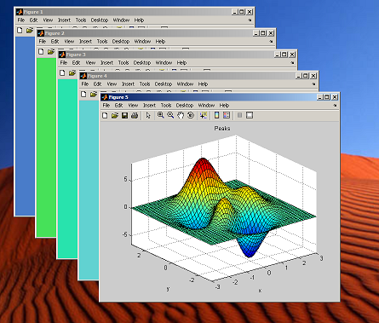

If you have **CS_HREDRAW** or **CS_VREDRAW** in your WNDCLASS, resizing will trigger a full repaint.

* CS_HREDRAW means "Redraw the entire window horizontally when its width changes."
* CS_VREDRAW means "Redraw the entire window vertically when its height changes."

🔧 WM_PAINT — Proper Handling Structure

Here’s the standard way to handle WM_PAINT in your WndProc:



🧰 BeginPaint and EndPaint — Explained

These functions frame the painting operation:

BeginPaint():

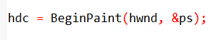

**Prepares the window for painting**, returns a handle to the Device Context (HDC).

Provides a **device context (DC) handle** for drawing in the client area.

The **DC handle** represents the physical output device (e.g., video display) and its associated driver.

EndPaint():

This function **completes the painting process** and marks the area as painted. It should be called after you've finished drawing, to release resources associated with the painting operation.

🧠 What’s HDC?

An **HDC (Handle to Device Context)** is how you draw **on the screen** — like a digital pen for the window.

Windows gives you one during BeginPaint, and you draw using functions like:

* TextOut
* DrawText
* Rectangle, Ellipse
* MoveToEx, LineTo

📦 PAINTSTRUCT Structure



This struct gives you info about the paint request. It’s filled out by BeginPaint.



**You mostly care about the first 3 members:**

hdc (Handle to Device Context):

* The **drawing context** used for painting operations. This is where all the graphical operations (like drawing lines, text, etc.) are performed.

rcPaint (Rectangle to be repainted):

* A **rectangle** that defines the area of the **client area** that needs to be repainted. It tells you what part of the window requires updating.

fErase (Erase Background Flag):

* A **flag** that indicates whether Windows expects you to erase the background before painting. If TRUE, you should erase the background; if FALSE, you don't need to erase it.

dwRop (Raster Operation Code):

* A **raster operation code (ROP)** that defines how the new content should be combined with the existing content. It controls how drawing operations interact with what's already on the screen (like blending, masking, etc.)

Once the painting is complete, the **EndPaint function** is called to release the DC handle:

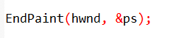

**Releasing the DC** ensures that the handle is no longer valid and prevents unauthorized access to the device or unintended drawing operations.

The **BeginPaint** and **EndPaint** functions mark the beginning and end of the painting process, respectively, and the **PAINTSTRUCT structure** provides relevant information for efficient client area repainting.

🧪 Drawing Text Example

Here’s how you draw centered text inside the window:



DrawText automatically wraps or aligns text based on the flags you provide.

GetClientRect retrieves the entire drawable area of the client window.

Flags like DT_CENTER, DT_VCENTER, and DT_SINGLELINE center the text **horizontally** and **vertically**, and ensure it remains on a **single line**.

🔁 Why You Must Use BeginPaint / EndPaint (Not Just HDC Alone)

Windows tracks which parts of your window are "dirty" (need repainting).  
If you skip BeginPaint, Windows won't properly reset that "dirty" status, and your app may:

* Miss redraws.
* Flicker.
* Use too much CPU.

Always use the **BeginPaint → draw → EndPaint** pattern inside WM_PAINT.





This is where beginners either **level up fast** or stay confused forever if it’s not explained right. Let’s dive deeper:

🧠 WM_PAINT — Advanced Redrawing Flow with Centered Text

🏎 Role of WndProc in WM_PAINT

When a window’s **client area becomes invalid**, Windows sends WM_PAINT to the window procedure. Your job in WndProc is to:

* Prepare the painting context
* Determine **where and what** to draw
* Execute the drawing code (text, shapes, images)
* End the painting session

⚠️ **If you don’t handle WM_PAINT**, you *must* call DefWindowProc to allow Windows to at least **validate the region** and avoid visual glitches.

📐 Retrieving the Drawing Area with GetClientRect

To center anything (like text), you need to know the size of the window’s **client area**. That's what GetClientRect does.



📎 What’s in RECT?



* left and top usually represent the **coordinates of the top-left corner** of a rectangle, which is typically (0, 0).
* right represents the **width** of the rectangle.
* bottom represents the **height** of the rectangle.

So, for a window with a size of **800x600**, the RECT would look like this:  
{ left = 0, top = 0, right = 800, bottom = 600 }

This means the rectangle starts at the top-left corner (0,0) and extends to the bottom-right corner (800,600).

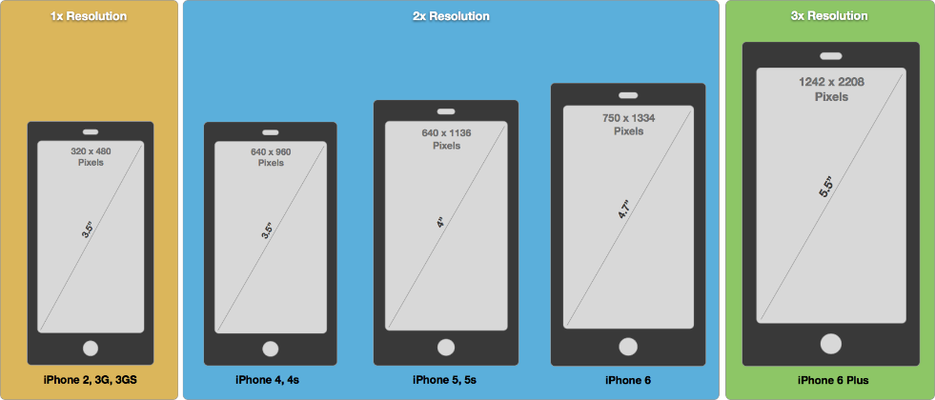

✍️ Drawing Text with DrawText

This is how HELLOWIN displays **"Hello, Windows 98!"** centered in the client area:



hdc: This is the **device context** obtained from BeginPaint. It’s the "drawing surface" where you perform all your painting operations (like drawing text, shapes, etc.).

lpszText: This is the **text string** you want to draw. It contains the characters that will be rendered to the screen.

cchText: This is the **number of characters** in the string. If you pass -1, it tells the function to use a **null-terminated string** (meaning it will automatically detect where the text ends based on the null character '\0').

lprc: This is a **pointer to a RECT structure** that defines the area where the text should be drawn. It gives the boundaries within which the text will be rendered.

wFormat (flags): These are **drawing options** that control how the text is positioned or formatted. For example:

* **DT_CENTER** centers the text horizontally.
* **DT_VCENTER** centers the text vertically.
* **DT_SINGLELINE** ensures that the text stays on one line, truncating or clipping it if necessary.

Want to wrap long text in a box?

To make text wrap inside a box, you should **remove DT_SINGLELINE** and use **DT_WORDBREAK** instead.

**DT_WORDBREAK** makes the text wrap to the next line whenever it reaches the edge of the defined rectangle, so it doesn’t overflow outside the box.

🔁 Handling Repaint After Resize or Restore

Every time your window is resized, uncovered, or restored, WM_PAINT fires again.  
Using GetClientRect() ensures that your content stays **centered** inside the updated dimensions.

That means this code:



...will always adjust to the new size. It's responsive drawing, the OG way 💻



WM_DESTROY — Window Destruction & Cleanup

What Triggers WM_DESTROY?

The WM_DESTROY message is triggered when:

* The user clicks the close button (❌) on the window.
* A PostMessage(hwnd, WM_CLOSE, ...) is sent to the window.
* The system shuts down or the parent window is destroyed.

What to Do When Handling WM_DESTROY?

When the WM_DESTROY message is received, this is your opportunity to:

* Free any allocated memory.
* Stop any timers that are running.
* Save any important data.
* Perform any final cleanup before the program exits.

What Does PostQuitMessage(0) Do?

Calling PostQuitMessage(0) places a WM_QUIT message into the application's message queue. This message signals that the application should terminate.

When GetMessage() receives this message, it returns 0.

The return value of 0 causes the message loop in WinMain to end, which leads to the closure of the application.



Why Use PostQuitMessage()?

PostQuitMessage() is the proper way to terminate your application cleanly. Here’s why:

Without it, your window may close, but the application itself could remain running in the background. This means that the message loop would continue to process other messages, keeping the app in memory.

Using PostQuitMessage() ensures that the app exits cleanly and *releases all resources* properly.

In simple terms, **PostQuitMessage() tells your app to die cleanly.** Without it, your window might disappear, but the application will keep running behind the scenes.

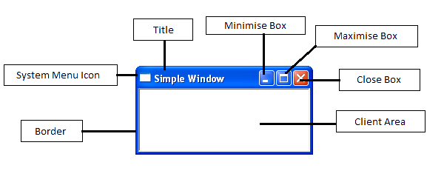

The WM_DESTROY Message in Action: HELLOWIN's Response

In the **HELLOWIN** sample application, when the WM_DESTROY message is received, it triggers the program to call PostQuitMessage(0):

This inserts a **WM_QUIT message** into the message queue, which **signals that the message loop should end**, which leads to the termination of the application.

BUCKLE UP, WE’RE ABOUT TO DO A READING SESSION NOW, TECHNICAL STUFF LATER

Shifting from Character-Mode to Message-Driven: What’s the Big Deal? 🤔

When you’re coming from **character-mode programming**, you’re used to writing a big chunk of code that runs from top to bottom. You call functions directly, and everything happens in order. **It’s like having a script where you control the flow.** 📝

But in **Windows programming**, things work differently. The program doesn’t just run in a straight line. Instead, it **reacts** to messages from the system or user actions (like clicks, key presses, etc.) 📨.

In other words, your program **waits** for things to happen, then reacts to those events. So, instead of controlling everything yourself, the **system is sending messages** that tell the program what to do. It’s like getting a text saying, “Hey, can you do this?” and your program responds to those texts. 📱💬

The Core of Windows Programming: The Message Loop & Window Procedures 🔄

At the heart of every Windows program is the **message loop**. 🌀 It’s like the **program’s "heartbeat,"** constantly checking the message queue for new tasks (messages) and sending them to the **window procedure** (WndProc).

* Message Loop: This loop is the part of the program that’s always running, like a busy receptionist who keeps checking the inbox for new tasks. 📥
* Window Procedures (WndProc): These are functions that handle specific tasks for each window. For example, when the user clicks on a button or types a letter, the window procedure decides how to respond.

So, instead of writing a long, straight function where everything happens in order, Windows apps react to messages, and the **WndProc** decides what to do with each one. 🚪👨‍💻

HELLOWIN: A Simple Example of Message-Driven Programming 🎬

Think of **HELLOWIN** as a tiny demo that shows off this message-driven world.

The WinMain function (which sets up your app) is just the beginning—**it registers the window, creates it, and sets everything up**.

But the real magic happens in **WndProc**, where the program reacts to messages like WM_CREATE (when the window is created), WM_PAINT (when the window needs to be redrawn), and WM_DESTROY (when it’s time to clean up). 🎨

So, **HELLOWIN** is like a mini-drama where the program listens to what’s happening and responds based on what the system or user does. 🎭

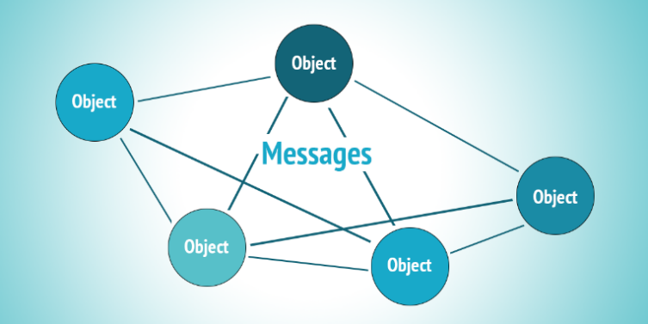

Conceptual Leap: Reactive Programming Style 🧠➡️👨‍💻

Moving from **character-mode programming** to **Windows programming** is like switching from being the director of a movie (where you control everything) to being an actor who reacts to the script and direction from the producers (messages). 🎬🎥

In **Windows programming**, you don’t control the flow of the program directly. Instead, you react to the messages that come in. This **reactive style** is crucial for making **interactive apps** that respond to user actions (like clicks, typing, etc.).

It’s a different mindset—you’re not always telling the program what to do; you’re waiting for messages and handling them as they come. It’s like getting messages and responding to them in real-time. 📲💥

A Shift in Paradigm: From OS Calls to Message Handling 🌐🖥️

In regular programming, you call functions like fopen to open a file or printf to print text. You **initiate the action** yourself.

But in **Windows programming**, the OS itself takes the lead by sending **messages** to your program’s window procedure. It’s like the OS is sending you a to-do list, and you handle it, instead of you constantly asking the OS for things. 📨

So, instead of saying, “Hey, OS, do this for me,” Windows programming flips the script: the OS says, “Hey, app, here’s a message—respond to this!” 🔄

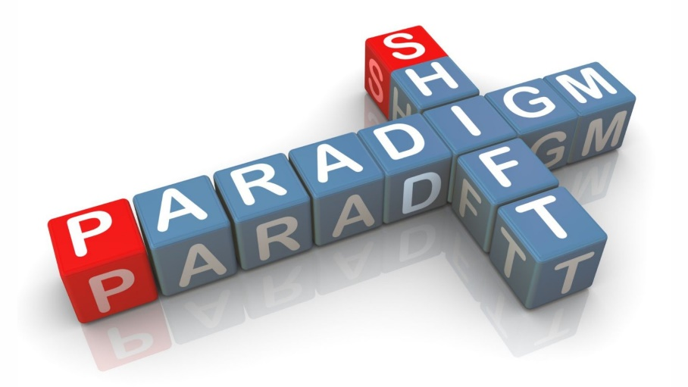

TLDR:

* **Character-mode programming** = You control everything, step-by-step.
* **Windows programming** = Your program reacts to messages sent by the system or user.
* **Message loop & window procedures** are the key—your program is always listening for new tasks and reacting to them.
* In **HELLOWIN**, WinMain sets up the app, but **WndProc** does the work based on incoming messages.
* **Post-Character Mode** = A **reactive mindset** where you handle messages instead of controlling everything directly.

Hope that made sense for both the new wave, GenZs and the classics, boomers! 😎📲



The Role of the Window Procedure 🖥️💻

The **window procedure (WndProc)** is like the **middleman** between your app and the operating system (OS). Think of it as the person at the helpdesk who takes requests and makes sure they get done. 🧑‍💻

Here’s the deal:

* It gets **messages** from the OS, like when someone clicks the mouse or presses a key.
* Then, it handles the appropriate actions, like updating what’s on the screen, responding to clicks, or even saving some data. 📲

The **WndProc** is tied to a **window class**, which you register with RegisterClass. It's the "identity" of your window, and the window procedure is **where the action happens**. 🔑



Windows Initiating Actions Through Messages 📩💥

In Windows programming, the **OS** doesn’t wait for your app to ask it to do stuff.

Instead, **Windows sends messages to your app’s window procedure** when something happens—whether it's a user click, system event, or something else.

These **messages usually start with WM (like WM_SIZE, WM_CREATE)** and are defined in the WINUSER.H header file. 📝

These messages let your app know exactly what’s going on, so it can react accordingly. It’s like getting a text message that says, “Hey, something happened—handle it!” 📲

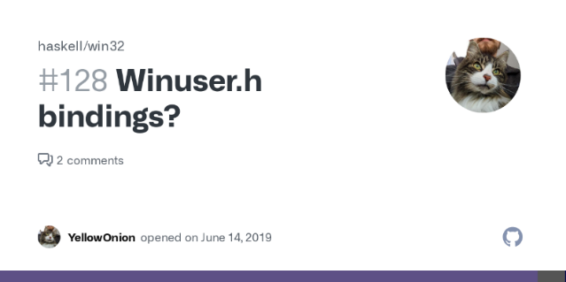

Examples of Message-Driven Interactions 🚨🔑

Here are some classic examples of when Windows sends messages to the window procedure:

* **When the window is created**: (WM_CREATE) 🆕
* **When the window is resized, moved, or minimized**: (WM_SIZE, WM_MOVE, WM_MINIMIZE) 📏
* **When the user clicks the mouse**: (WM_LBUTTONDOWN, WM_RBUTTONDOWN) 🖱️
* **When characters are typed**: (WM_CHAR) ⌨️
* **When a menu item is selected**: (WM_COMMAND) 🍔
* **When a scrollbar is clicked or moved**: (WM_HSCROLL, WM_VSCROLL) 📉📈
* **When the window needs to repaint**: (WM_PAINT) 🎨

Basically, messages = events, and the window procedure is where you handle each of those events. 🎮

Handling Messages and Default Processing 🔄📝

Your window procedure **handles the messages** and takes action, whether that’s:

* Updating what’s on the screen 🖥️
* Responding to a user input 🖱️
* Validating data ⏳

If for some reason your window procedure doesn’t handle a specific message, it **forwards** the message to **DefWindowProc.** This is like handing the message to a backup handler that’ll do the default thing.

So, if your app’s not sure what to do with a message, **DefWindowProc** is the “catch-all” backup plan. 🛠️

wParam and lParam: Extra Info 💡💬

These two parameters, wParam and lParam, are like **extra details** that come with each message. They give your window procedure **extra context** for handling the message. 🧠

* **wParam** often holds information like **key codes** or **mouse button states**.
* **lParam** can contain more detailed data, like **coordinates** or **additional flags**.

These vary depending on the message, but they give your app the full picture of what’s happening. 🖼️

Comparison to Character-Mode Interrupt Handling ⏳➡️📞

In **character-mode programming**, you might be used to handling things like **Ctrl+C** to interrupt your program (like a **signal function** in C). 🚨 This is somewhat similar to **interrupts** in older programming systems like MS-DOS.

But in **Windows programming**, it's more than just handling interruptions. **Now, the OS actively sends messages** to your program, and your app **responds** to those messages to keep things running. 🏃‍♀️

It’s like the OS is **calling the shots** and your app is just reacting, making Windows programming much more **event-driven** than what you might be used to in older, more linear coding styles. 🔄

TLDR:

* **Window Procedure (WndProc)** is the middleman between your app and the OS, handling incoming messages.
* Windows sends **messages** (like clicks, keyboard presses, etc.) to your app, and the **window procedure** responds to these events.
* If your window procedure doesn’t know how to handle a message, it can **pass it to DefWindowProc** for default behavior.
* The **wParam** and **lParam** parameters are like extra details that help you handle messages correctly.

Boom! That’s how the **message-driven** programming works in Windows! 😎📲

LET’S DO SOME EXAMPLES SO THAT PEOPLE GET THIS STUFF

This comparison between **character-mode interrupt handling** and **Windows message-based architecture** is a game-changer for new devs.

Most beginners don’t realize how **radically different** Windows GUI apps are compared to old-school, terminal-based programs.

We’re gonna:

* Explain what character-mode programming is (with code).
* Contrast it directly with WinAPI and the message loop.
* Build a clear table of differences.
* Give examples in C for both styles — so you can see the shift.

🧾 What is Character-Mode Programming?

**Character-mode programming** refers to software that runs in a **text-only environment**, like:

* DOS programs
* Console apps (Command Prompt)
* Embedded/low-level apps with no GUI
* Linux terminal tools

Everything is drawn using **text characters**, not pixels, windows, or UI controls.

📍Common Languages:

* **C** (classic)
* Pascal
* Assembly
* Early BASIC
* Shell scripts (on Unix/Linux)

⚠️ Interrupt Handling in Character Mode

In character-mode apps, you're usually in **control of the main loop**, and the OS only interrupts you in **specific cases** (like **Ctrl+C**, or a **timer firing**).

Example in C (MS-DOS style):

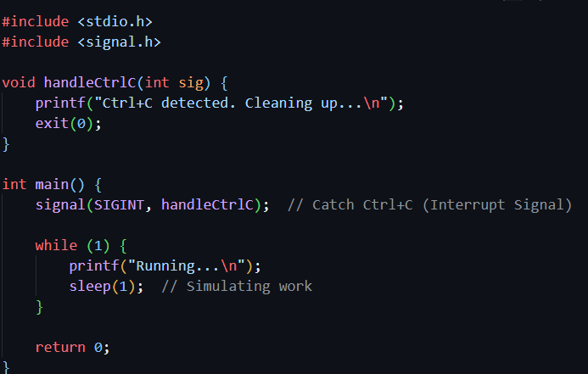

This program just **loops forever — until** an external interrupt (like Ctrl+C) breaks it. Then, your handler runs. That’s character-mode interrupt handling.

🎯 Now Enter Windows GUI World: Message-Driven Architecture

In Windows programming, **your app doesn’t control the main loop.** The OS drives everything through **messages**, and you react to them inside your WndProc.

It’s not just about handling **one or two interrupts** — it’s about reacting to **hundreds of possible events**, constantly.

Example: Windows GUI Skeleton

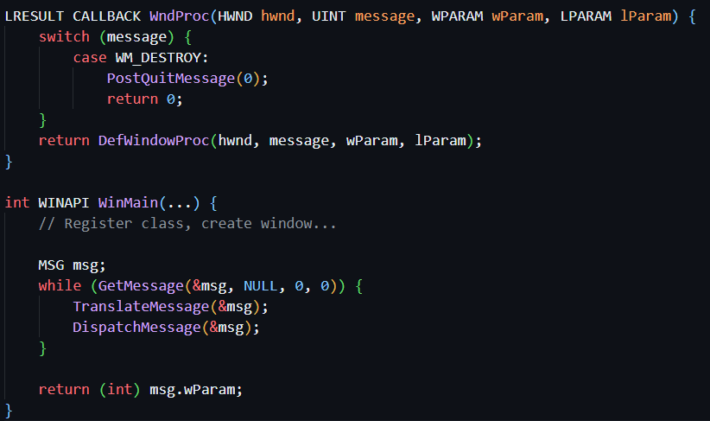

Your app does nothing until Windows sends a message (like a keypress or mouse click), and then it **reacts**.

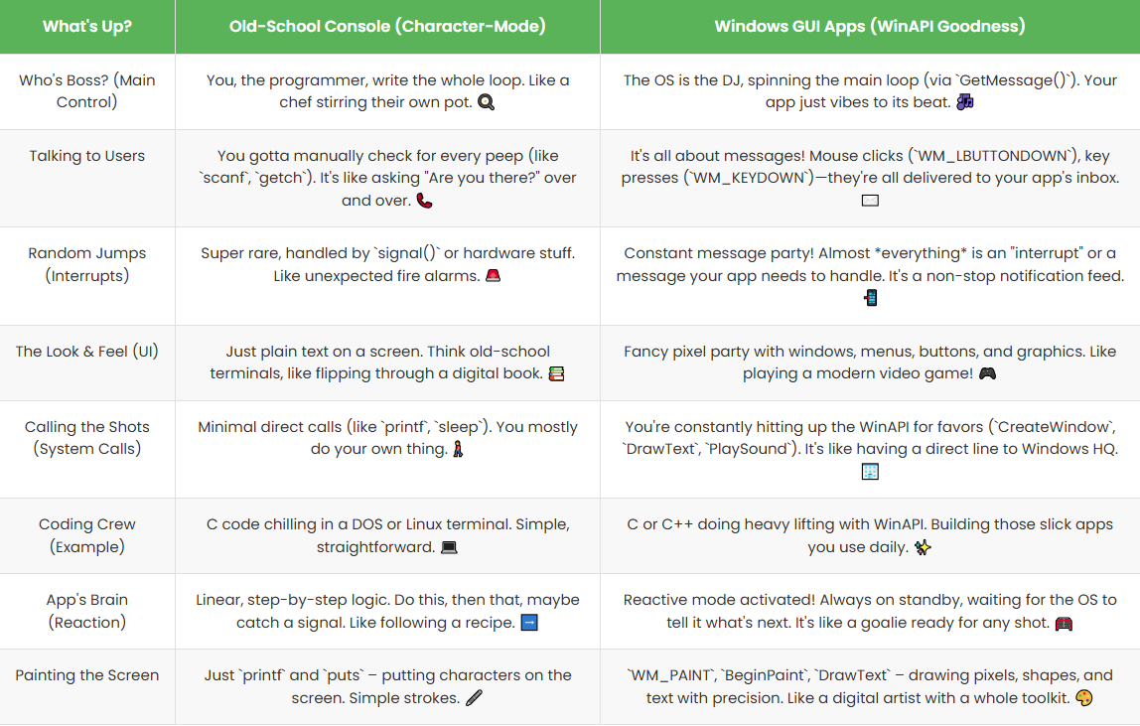



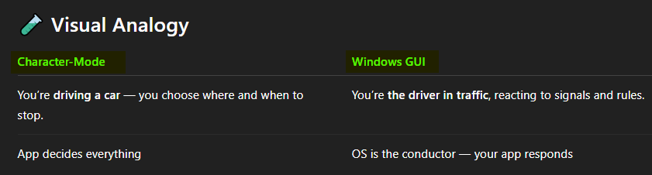

Handling Window Size Changes: An Example of Message Processing

When you're working with Windows programming, your program doesn't just run its own loop or wait for you to tell it what to do.

The **operating system (OS) is constantly sending messages**, and your program has to respond to them.

One key message you'll often handle is the **WM_SIZE message**, which happens when the **window size changes**.

So, for example, when you resize the window (or maximize/minimize it), this message gets **sent to your program to tell it the window's new size.**

Let’s walk through how your program (specifically the **window procedure**) handles this type of message:

1. Identifying the Window and Message Type 🏷️

* **The hwnd parameter** in the window procedure tells your program exactly which window is being resized (since you might have multiple windows in your app).
* This is **important** because if you’re **managing several windows** from the same class, your program needs to know which one to adjust.

2. Extracting Size Information from wParam and lParam 🔎

* **wParam**: This tells you what type of resizing is happening:
  + **SIZE_RESTORED (0)**: The window is being restored to its original size.
  + **SIZE_MINIMIZED (1)**: The window is minimized (hidden).
  + **SIZE_MAXIMIZED (2)**: The window is maximized (full screen).
  + **SIZE_MAXSHOW (3)**: The window is shown after being maximized.
  + **SIZE_MAXHIDE (4)**: The window is hidden after being maximized.
* **lParam**: This parameter is a bit more complex because it contains both the **width** and **height** of the new window. 🖼️
  + The **16-bit width** and **16-bit height** values are combined into a **single 32-bit number**.
  + There are special **macros** in the **WINDEF.H** header that help you separate the width and height from this combined value. 🛠️

3. DefWindowProc's Role in Message Handling 🖥️

If your window procedure doesn’t **handle a specific message** (like WM_SIZE, for example), it can **pass the message** along to the default **DefWindowProc** function. This function acts as a **safety net**—it processes the message with the **default behavior**.

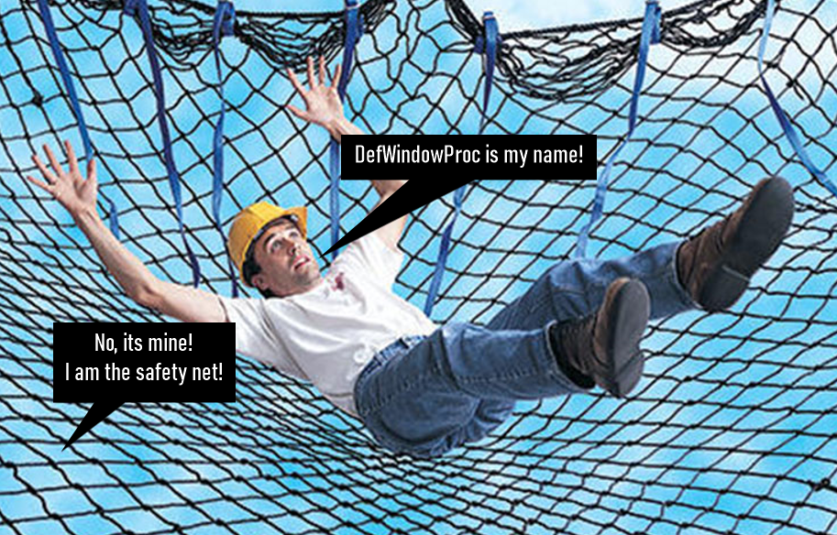

4. Message Cascading: Handling Multiple Messages 🔄

Sometimes, **one message triggers another**. This is how **closing a window** works in Windows programming. Here’s the typical chain of messages that happen when a window is closed:

1. **User clicks Close button (or selects Close from the system menu).**
2. **The system sends a WM_SYSCOMMAND message to the window procedure.**
3. **The window procedure passes this message to DefWindowProc.**
4. **DefWindowProc sends a WM_CLOSE message to the window procedure.**
5. **The window procedure passes it back to DefWindowProc.**
6. **DefWindowProc then calls DestroyWindow.**
7. **DestroyWindow triggers the WM_DESTROY message.**
8. **Finally, the window procedure calls PostQuitMessage, which adds a WM_QUIT message to the message queue, telling the message loop to exit.**
9. **The WinMain message loop detects the WM_QUIT message, ending the program.**

This is a **cascade** of messages! Each one triggers the next until the app is properly shut down. This shows how **message-driven** Windows programming works: ***everything is connected and controlled by messages.*** 📩

The Big Picture: The WM_SIZE Example 🔄

The **WM_SIZE message** is just one example of how Windows programming handles events through messages.

The **window procedure** receives these messages and extracts information (like the new window size), performing the necessary action (like updating the window size).

If your window procedure doesn't handle a message, it lets **DefWindowProc** do the default processing. It's like having a built-in backup plan when you don’t specifically tell the program what to do.

TLDR (Too Long; Didn't Read):

When a window is resized or moved, Windows sends the **WM_SIZE message** to your program, and your program (via the window procedure) handles it.

The process involves extracting window size info from the message, and if needed, passing messages to **DefWindowProc** for default handling.

This is all part of **message-driven programming**, where Windows constantly sends messages, and your program responds accordingly. 👨‍💻📱

🔀 Queued vs Nonqueued Messages — Deeper Message Handling

In Windows programming, **messages are the language** between:

* the **OS**
* your **program**
* and the **user**

Every click, keypress, resize, or window update triggers a **message** that your program needs to handle. These messages come in two main forms:

📮 1. Queued Messages — Go Through the Message Queue

These are messages placed into your **program’s message queue** by Windows, waiting to be processed by your **message loop** (GetMessage → TranslateMessage → DispatchMessage).

🔁 Flow:

1. User presses a key or moves the mouse
2. Windows places a message (e.g., WM_KEYDOWN, WM_MOUSEMOVE) into the queue
3. Your message loop retrieves it:

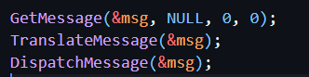

Windows then calls your WndProc() with the message.

📌 Examples of Queued Messages:

* WM_KEYDOWN, WM_KEYUP – keyboard press/release
* WM_CHAR – actual typed characters (after TranslateMessage)
* WM_MOUSEMOVE, WM_LBUTTONDOWN – mouse events
* WM_TIMER – timer events via SetTimer
* WM_PAINT – repaint request when *Windows* triggers it (e.g. after a resize)
* WM_QUIT – when PostQuitMessage() is called

⚡ 2. Nonqueued Messages — Sent Immediately to WndProc

These messages **bypass the message queue entirely** and go straight to the window procedure. They’re typically triggered by **function calls** or **system actions** (not user input).

⚠️ Why?

Because some actions need to happen **immediately**, like when a window is being created — there’s no point queueing that.

📌 Examples of Nonqueued Messages:

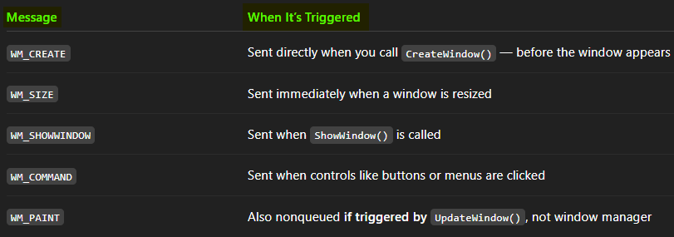

🧠 Handling Both: Role of the Window Procedure

Whether a message is queued or nonqueued, it **always ends up in your WndProc**:

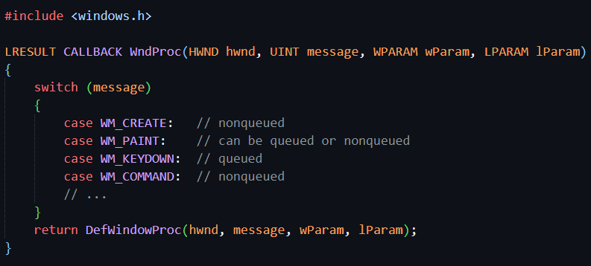

🧠 Multiple Threads = Multiple Message Queues

In a **Windows app**, each **thread** (you can think of a thread like a separate task or process) has its **own message queue**.

Imagine you have a **super busy office** where lots of people (threads) are working on different tasks (windows). 🏢

Each person (thread) has their **own inbox (message queue)**. When a message comes in (like someone asking you to do a task), it goes into **your inbox** — not someone else's. 📬

This ensures that:

1. Messages go to the right person (thread): If a message is about a task for Person A (thread A), it goes to their inbox (message queue), not someone else's. 🧑‍💻
2. Things stay in order: Person A will get their tasks in the right order, without someone else stealing their tasks. This helps **keep things thread-safe** (everyone does their job without messing up others’ work). ✅

What Happens in Multi-Window Apps? 🧵

Now, if you're building an app with **multiple windows**, it can get a bit more complex. Imagine you have multiple departments in your office. Each department is working on different projects (windows). 🏢🖥️

If each **department** (window) is being run by a **different person (thread)**, **messages** related to that window will go into the **message queue** of the **thread** that is handling that window. 📨

So, when a **message** comes in (like someone clicking a button or typing in a window), **that message will go to the thread** that **owns** that window.

For example:

* **Window A** is handled by **Thread A**, so any message about Window A will go to **Thread A's message queue**.
* **Window B** is handled by **Thread B**, so any message about Window B will go to **Thread B's message queue**.

Why Is This Important? 🤔

This setup is super important for **multi-threaded applications** because:

* It makes sure **each thread is focused on its own work** (handling messages for its own window).
* It keeps the app **thread-safe**, so there’s no confusion about which thread should be doing which work. 🔒
* It allows for more **efficient** handling of multiple windows and interactions at once. 💨

TLDR:

In **multi-threaded Windows programming**, each thread has its **own message queue**. This way, each thread gets the messages related to its own window, making sure the app is **organized** and **thread-safe**. If a window is created by a thread, its messages will be delivered to that thread’s queue. It's like each person in an office having their own inbox for messages! 📬

Maintaining Context Between Messages 🧊

In Windows programming, messages are short and stateless, meaning each message doesn’t **remember anything** from previous ones. So, if you want to keep track of **things** (like window size or user settings) between messages, you have to handle it **manually**.

Two Ways to Store State 📝:

1. **Static Variables inside WndProc** 📍
   * You can use **static variables** inside your **window procedure (WndProc)**.
   * These **preserve their value** between calls to WndProc. It’s like keeping a **notepad** that you write on during each message, and the notes stay there for the next message.
2. **Global or App-Level State 🌍**
   * You can store the state **outside** of WndProc, using **global variables** or other app-level structures.
   * This allows your program to share data across **multiple windows** or messages, such as tracking the **window size**, flags, or counters that need to be accessed from anywhere in the program.

In Simple Terms:

* **If you need to remember stuff** (like a setting or size change) between messages, you can store it in **static variables** (inside WndProc) or **global variables** (for the whole program).
* Whenever a new message arrives, you **access the stored data** to **keep track of what's happening**.

📊 Comparison Table: Queued vs Nonqueued Messages

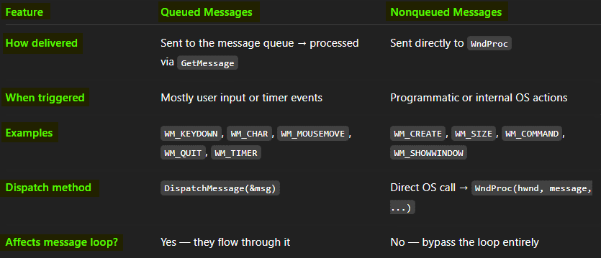

✅ Final Summary: Why This Matters

* **Queued messages** let the OS organize and schedule user/system events without overwhelming your app
* **Nonqueued messages** give the OS and your app a way to immediately respond to internal events
* Both go through your WndProc, where you decide how to handle them
* This architecture gives Windows apps their responsiveness, flexibility, and control flow

Let me know if you want to move next into:

* WM_COMMAND (handling buttons, menus)
* Keyboard input in detail (WM_KEYDOWN vs WM_CHAR)
* Message queues in **multithreaded apps**
* Or creating custom messages (WM_USER + N)

MANAGING MESSAGE DELIVERY: ORDER, SYNCHRONIZATION, AND REENTRANCY

Windows programming involves a complex interplay of messages, message queues, and window procedures.

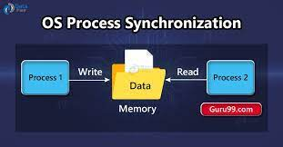

While the underlying mechanisms may seem intricate, the window procedure experiences a **well-ordered** and **synchronized flow of messages.**

1) Orderly Message Delivery: No Mid-Processing Interruptions

*“Unlike hardware interrupts, messages arrive at the window procedure in an orderly fashion.”*

When messages come into your program's WndProc (Window Procedure), they do so in a very orderly way. Unlike **hardware interrupts** (which can happen at any time), **messages** to your window procedure come one at a time. This means:

* Only one message at a time: Your WndProc handles one message at a time. It won't get distracted by another message while it's still processing the current one. 🧑‍💻
* No interruptions: Windows doesn’t interrupt the message that's currently being processed. So, if you’re dealing with a message (like someone clicking a button), no other message will sneak in and mess up what you're doing. 📭
* Code runs smoothly: You can rely on your code running without being interrupted by other messages. It’s like a single-file queue where everyone waits their turn.

Why This Matters 🧠

Because messages are processed one at a time, **you don’t need to worry about things like locks or mutexes** (which are tools to stop multiple things from happening at once).

Here’s why:

* In multi-threaded programming, you usually need to ensure things don’t happen at the same time (e.g., two things trying to access the same resource), which requires using locks or mutexes.
* But inside WndProc, since messages are handled in order and never interrupt each other, you don’t need those tools. Everything’s already serialized (processed in order) automatically by Windows. 🎯



Simple Analogy:

Think of a single line at a coffee shop. The barista (your WndProc) handles one customer at a time (one message). No one jumps the line (no interruptions). You don't need to worry about the barista mixing up orders, because everyone’s waiting their turn.



TLDR:

In Windows, messages arrive one at a time and don’t interrupt each other. This means your program doesn’t need extra protection like locks or mutexes — it’s already set up to handle things in a smooth, orderly fashion. 📑

2) Thread-Specific Message Queues 🧵

In Windows, **each thread** has its **own message queue**. This means that every **thread** in your program, especially for a GUI app, will keep its **messages separate** from other threads.

What It Means ✅

* If you have multiple windows, each window's messages are managed by the thread that created that window. 🖥️
* *For example: If Thread A creates Window A, then Thread A will handle Window A's messages.*
* *Window B, created by Thread B, will only have its messages handled by Thread B.*
* No Cross-Thread Message Chaos: Windows ensures that each thread’s messages are kept separate, so you don’t have to worry about confusion between threads. 🎯

Why It Matters 🧠

* Thread-Specific Queues prevent mixing up messages between threads. This is good because: It keeps everything organized and avoids unexpected behaviors where one thread might mess with another's window. 😎
* But if you need to communicate between threads, you have to use special methods to send messages safely:

PostThreadMessage:

This is used when you want to send a message **directly** to another thread’s message queue. Think of it like sending a letter straight to a friend (another thread). 📬

SendMessage:

You can use this to send messages **between threads**, but you should be **careful** with it because it can block the thread and may cause **deadlocks** (two threads waiting for each other forever). 🛑

Simple Analogy:

Imagine you have two **separate office rooms** (threads), and each room has its own **inbox** (message queue).

* In **Room A**, all the **messages** for **Window A** are handled by **Thread A**.
* In **Room B**, **Thread B** handles **Window B's messages**.

If you want to send a **message** from **Room A** to **Room B**, you have to use a **special method** to do so — just like passing a note through a **direct messenger** (PostThreadMessage) or through a **central office** (SendMessage).

TLDR:

**Each thread** in your program **has its own message queue** to keep messages for **its windows separate**.

If you need to send messages between threads, use **PostThreadMessage** or **SendMessage**, but be cautious with the latter. It keeps everything **organized** and prevents **chaos** between threads. 🚦

3) DispatchMessage — Waits for WndProc to Finish 🔄

When **DispatchMessage()** is called, it **waits** until your **WndProc** finishes processing the current message before it moves on to the next one.

What It Means ✅

* **DispatchMessage()** tells **Windows** to send a message to your **WndProc** (the function that handles messages for your window).
* **It calls WndProc synchronously**, meaning it waits for **WndProc to finish** before it can move on to the next message.

In other words, **DispatchMessage** doesn’t just pass the message and move on — it **waits** until your window procedure has **completed processing** the message. 🕒

Why It Matters 🧠

* If your **WndProc** is **slow** or has **heavy code** inside it, then it **blocks** everything else while it’s running.
  + This means that if you’re doing something like:
    - Handling a mouse click 🖱️
    - Redrawing the window 🖼️
    - Even quitting the program with **Alt+F4** 🚪

All of those actions would **get delayed** because **WndProc** is busy.

**DispatchMessage** is waiting for **WndProc** to finish before it can process any new messages.

Simple Analogy:

Think of **DispatchMessage** as a **gatekeeper** that’s waiting for you to finish talking before it lets anyone else in the room. 🧑‍⚖️

If you're taking **too long** (doing slow work in **WndProc**), everyone else (other messages) has to **wait their turn** before they can come in.

TLDR:

**DispatchMessage()** waits for your **WndProc** to finish processing the current message before it moves on to the next one. If your **WndProc** is slow, **everything else** (mouse clicks, window updates, etc.) gets **blocked** until it finishes. 🚫

🧨 4. Reentrancy — Handling Nested Messages

“Window procedures must be reentrant.”

In Windows programming, your **window procedure** (WndProc) **must be reentrant**. This means it has to be able to handle new messages **even while it’s processing other messages**. Let's break it down:

What It Means ✅

* Windows can send new messages to your program while your message loop is still running. For example, if you call a function like SendMessage() inside WndProc, that call can trigger WndProc again before it finishes handling the first message.
* This is called **reentrancy** — when your code is **re-entered** before the first call is finished. 🌀

Why It Matters 🧠

* Reentrancy can be **dangerous** if you’re not careful. If you use **shared or static variables** inside WndProc, multiple calls might mess with them at the same time.
* Imagine you have a **counter variable** that's being updated. If **WndProc** enters again before the first call finishes, both calls might try to change the **counter** simultaneously, causing **bugs** or **incorrect behavior**.
* **Key Point**: You need to ensure that each message is processed **independently** and **without interference** from others.

Your code should be written so that it can safely handle **nested messages** (messages coming while others are still processing) without stepping on each other's toes. 👣

5. Preserving Context: Static or Global Variables 📦

To keep track of information across **multiple messages**, you can use **static** or **global variables**. This is especially useful when you want to **preserve context** between message calls.

What It Means ✅

* **Static variables** like static int counter = 0; can preserve **state** (like a counter) between **WndProc** calls.
* **Global variables** like global bool isDragging; are useful when you need to share information across **multiple windows** or even between different **types of events** (like dragging an object across the screen).

Why It Matters 🧠

* In reentrant contexts or multithreaded apps, you must be careful when using static or global variables. If **nested messages** (like another WndProc call) are trying to change the same variable at the same time, it could lead to **incorrect values** or **bugs**.
* **Good Practice**:
  + If you **need to preserve state**, use **static** or **global variables**, but be aware of the risks.
  + If you're working in a **reentrant or multithreaded** environment, consider: Wrapping your state inside a **struct** or **context manager** to safely manage shared data. This ensures that changes to shared state happen in a controlled way.

Simple Example of Static State:

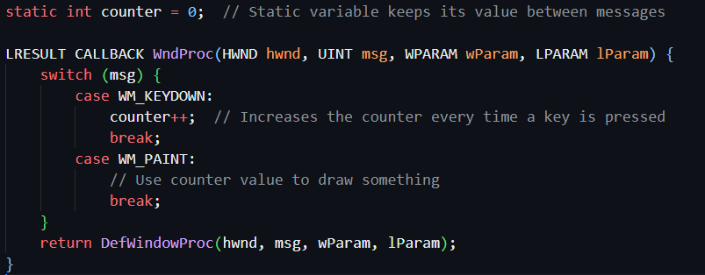

Here, the counter keeps track of **how many times a key was pressed**, even across different **WndProc calls**. ⚡

TLDR:

* **Reentrancy** means your WndProc can handle new messages while it’s still processing others. But this can cause problems if you use shared or static variables improperly.
* To preserve context across messages, **static** or **global variables** are useful, but be careful in **multithreaded** or **reentrant** situations to avoid messing with data mid-processing. Consider using a **struct** or **context manager** to safely store state. 🛡️

🚨 6. Compiler Optimization Hazards

*"Some optimizations can break reentrant behavior."*

What It Means ✅

When you're compiling your C/C++ code, the **compiler** might try to optimize it for **speed** using certain flags (like /O2 or /Ox), which could **reorder** or **cache variables** in **registers** for efficiency.

But here's the catch: **If you use these flags** and a **nested message** or **signal handler** *changes* one of these cached variables, the compiler won’t know about it. 💥 This can lead to **undefined behavior** where your program might crash or act unpredictably.

What to Do 🧠

* **Use volatile** on variables that are shared or sensitive to reentrancy. This tells the compiler not to optimize these variables, ensuring they stay accurate no matter how many times they're updated.

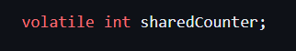

* **Disable aggressive optimizations** on functions like WndProc if needed. This prevents the compiler from making assumptions that can break things when messages are nested or reentered.

⚙️ 7. Windows is Preemptive — Your App Is Not

*"Preemptive multitasking means long tasks freeze the app."*

What It Means ✅

**Windows can multitask** across different applications, meaning it can switch between programs at any time without them having to tell it to. However:

**Your app, in contrast, does not preemptively multitask.** It must manually yield control during long operations.

Windows won't interrupt your message handling, even if it's busy doing heavy work.

Problem 🧠

If your **WndProc** is running **long tasks** (like:

* **Parsing a large file** 📂
* **Running complex calculations** 🔢)
* Your **window will freeze** — you can’t interact with it, move it, or close it.
* To the user, this looks like a **crash**, even though the program might be fine, it's just **blocked**.

🛠️ How to Fix: Break Up Long Tasks

Techniques ✅

* **Use PostMessage()** to break long tasks into smaller steps. This allows the message loop to process other messages, keeping the app responsive while doing heavy work. 🧩

Example:  
Post a message after every 1000 lines processed in a file.

* **Use SetTimer()** to run tasks in small **time chunks**. This prevents the UI from freezing by dividing work over time.
* **Offload work to a background thread**. This keeps the **UI thread** free for handling user input. Once the work is done, send the results back to the UI thread with **PostMessage()**.

📉 8. Don’t Leave the User Hanging

*"Unresponsive windows are bugs in disguise."*

What It Means ✅

* Even if your **logic** is correct, a **frozen window** or **unresponsive UI** gives the **impression** that something has gone wrong.
* If users experience:
  + **A frozen window** ❄️
  + **A greyed-out or non-moving UI** ⚪
  + **No response to clicks or input** ⏸️

... it's **bad UX**. And in many cases, it’s considered a **bug** even though your program might be working fine behind the scenes.

Fix By 🧠

* **Keep WndProc fast and responsive**. Avoid heavy operations in it.
* **Offload any long-running work** to other threads or break them into smaller chunks.
* **Let the message loop breathe**. Ensure that messages are processed without blocking the UI.

TLDR:

* **Compiler Optimization**: Don’t let optimizations break your code. Use volatile for sensitive variables and disable aggressive optimizations in critical functions like WndProc.
* **Preemptive Multitasking**: Windows multitasks across apps, but your app must **manually yield control** during long tasks. Don’t freeze your UI by performing long work in WndProc.
* **Don’t Leave Users Hanging**: Make sure the UI remains responsive. Use techniques like PostMessage(), SetTimer(), or background threads to prevent freezing.

🚨 Preemptive Multitasking: A Mixed Blessing

Windows (10, 11, and earlier versions like 98 and NT) are built on a **preemptive multitasking** model. What does that mean?

* **Preemptive multitasking** lets the operating system switch between different programs, even if one is doing something heavy. You could be browsing the web while listening to music, for example.
* But this can become a **problem** when your program is stuck processing a **long-running task**.

🧠 Impact of Lengthy Message Processing on User Interaction

When a program gets **stuck** processing a **big task** (like handling a huge file or running an intense calculation), it **blocks** the window from responding to user actions.

* Users **can’t**:
  + Move, resize, or minimize the window.
  + Close the program.
* This happens because the window procedure is still busy running that long task, so it can't process the usual user inputs like clicks or keypresses.

🔨 DefWindowProc's Role in Window Operations

The **window procedure** (WndProc) is responsible for handling user actions (like clicks or keypresses) and other tasks such as window movement, resizing, or minimizing.

* Normally, these tasks are **delegated to DefWindowProc()** to be handled smoothly.
* However, if the WndProc is tied up with long-running operations, **user actions** (like trying to move or resize the window) can get **blocked**.

🛠️ Mitigating the Impact of Lengthy Message Processing

Even though **preemptive multitasking** seems like it should let your app run multiple tasks at once, it requires careful management. Here’s how to handle those long tasks without freezing your app:

* **Post messages**: Break up the task into smaller chunks and send **messages** after processing each chunk. This lets Windows keep things moving while you finish the task.
* **Use idle time**: Take advantage of **idle time** to process the task incrementally, keeping the window responsive.
* **Background threads**: For big jobs, offload work to a **background thread**. This keeps the main UI thread free to handle user input.

😣 The User Experience: Avoiding Annoyance

An **unresponsive window** is like encountering a **bug** or **glitch** in a program—it’s frustrating, and can make users think the app is broken.

To keep your app **user-friendly**:

* Handle tasks **efficiently** in the window procedure.
* Make sure the app **doesn’t freeze**—users should always be able to interact with the program.
* Ensure that long-running tasks don’t block user actions.

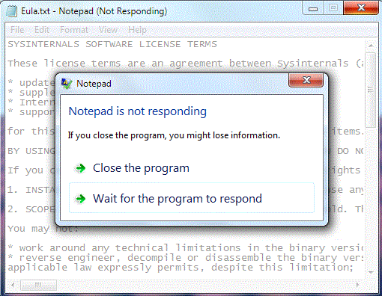

📝 Summary: Smooth and Responsive Message Handling

* **Windows message handling** is orderly and sequential, making sure each message is processed without interruption.
* **Message queues**, **thread-specific message handling**, and **DispatchMessage synchronization** ensure this smooth flow.
* But if you block the message loop with heavy tasks, the app becomes **unresponsive**.
* To **keep things smooth** for users, break up long tasks, use background threads, and make sure the window remains **interactive**.

In short, **keep your code responsive**, and your users will appreciate it! 💯 **That’s a wrap!** 💥

Understanding the message loop, thread management, and efficient message handling are crucial for creating smooth and responsive Windows applications.

Stay mindful of how your app interacts with the system, and always ensure a **snappy user experience**. 👨‍💻👩‍💻

~ Windows API.

